LAPORAN PRAKTIKUM
PEMROGRAMAN II
MODUL 6



SOLID PRINCIPLE DAN DESIGN PATTERN

Oleh:
Rizki Adhitiya Maulana | NIM. 2410817110014

PROGRAM STUDI TEKNOLOGI INFORMASI
FAKULTAS TEKNIK
UNIVERSITAS LAMBUNG MANGKURAT
NOVEMBER 2025

LEMBAR PENGESAHAN
LAPORAN PRAKTIKUM PEMROGRAMAN II
MODUL 6

Laporan Praktikum Pemrograman II Modul 6: SOLID Principle dan Design Pattern ini disusun sebagai syarat lulus mata kuliah Praktikum Pemrograman II. Laporan Praktikum ini dikerjakan oleh:

Nama Praktikan : Rizki Adhitiya Maulana
NIM : 2410817110014

Menyetujui,  Asisten Praktikum  Jovan Gilbert Natamasindah  NIM. 2310817310002 | Mengetahui,  Dosen Penanggung Jawab Praktikum  Irham Maulani Abdul Gani, S.Kom., M.Kom.  NIP. 199710312025061009

DAFTAR ISI
LEMBAR PENGESAHAN ii
DAFTAR ISI iii
DAFTAR GAMBAR iv
DAFTAR TABEL v
SOAL 1 1
A. Source Code 2
B. Output Program 13
C. Pembahasan 16
TAUTAN GIT 19

DAFTAR GAMBAR
Gambar 1. SOLID Principle 1
Gambar 2. Screenshot Output Pembuatan Karakter 13
Gambar 3. Screenshot Output Aktivitas Bertani 14
Gambar 4. Screenshot Output Aktivitas Menambang 14
Gambar 5. Screenshot Output Aktivitas Memancing 15
Gambar 6. Screenshot Output Aktivitas Menebang Pohon 15
Gambar 7. Screenshot Output Lihat Status Pemain 16
Gambar 8. Screenshot Output Istirahat 16
Gambar 9. Screenshot Output Keluar Dari Program 16

DAFTAR TABEL
Tabel 1. Source Code - Main.java - Implementasi Single Responsibility Principle 2
Tabel 2. Source Code - Game.java - Implementasi Single Responsibility Principle 2
Tabel 3. Source Code - MenuHandler.java - Implementasi Single Responsibility Principle 3
Tabel 4. Source Code - Player.java - Implementasi Single Responsibility Principle & Single Responsibility Principle 5
Tabel 5. Source Code - Activity.java - Implementasi Open/Closed Principle 7
Tabel 6. Source Code - Farming.java - Implementasi Liskov Substitution Principle 7
Tabel 7. Source Code - Fishing.java - Implementasi Liskov Substitution Principle 7
Tabel 8. Source Code - Mining.java - Implementasi Liskov Substitution Principle 8
Tabel 9. Source Code - Woodcutting.java - Implementasi Liskov Substitution Principle 8
Tabel 10. Source Code - Tool.java - Implementasi Open/Closed Principle 8
Tabel 11. Source Code - Tool.java – Implementasi Interface Segregation Principle 9
Tabel 12. Source Code - Axe.java - Implementasi Liskov Substitution Principle 9
Tabel 13. Source Code - FishingRod.java - Implementasi Liskov Substitution Principle 9
Tabel 14. Source Code - Pickaxe.java - Implementasi Liskov Substitution Principle 10
Tabel 15. Source Code - WateringCan.java - Implementasi Liskov Substitution Principle 10
Tabel 16. Source Code - ActivityDecorator.java - Implementasi Structural patterns - Decorator 11
Tabel 17. Source Code - LoggingActivityDecorator.java - Implementasi Structural patterns - Decorator 11
Tabe 18. Source Code - EnergyStrategy.java - Implementasi Behavioral patterns - Strategy 12
Tabel 19. Source Code - FixedEnergyStrategy.java - Implementasi Behavioral patterns - Strategy 12
Tabel 20. Source Code - ActivityTool.java - Implementasi Creational patterns - Factory 12
Tabel 21 Source Code - ActivityToolFactory.java - Implementasi Creational patterns - Factory 12

SOAL 1
Berdasarkan tugas CLI template yang telah anda buat masing-masing sebelumnya. Sekarang ubah atau lakukan refactor terhadap code CLI tersebut untuk menerapkan masing-masing prinsip SOLID
Gambar 1. SOLID Principle
Kemudian setelah melakukan implementasi dari SOLID, selanjutnya silahkan pilih masing-masing 1 design pattern dari 3 jenis design pattern untuk diimplementasikan ke kode tadi dari link ini https://refactoring.guru/design-patterns/catalog (kecuali singleton)
Catatan:
- Untuk format laprak sama seperti yang sebelum-sebelumnya.
- Untuk bagian source code, pisah jadi dua bagian, yaitu berisikan implementasi SOLID dan berisikan implementasi SOLID dengan design pattern yang dipilih.
- Untuk bagian penjelasan, hanya menjelaskan di bagian mana masing-masing bagian SOLID diterapkan dan penjelasan design pattern yang dipilih dengan detail.

Source Code
Tabel 1. Source Code - Main.java - Implementasi Single Responsibility Principle
1  2  3  4  5  6  7  8  9  10  11  12 | package DESIGN_PATTERN;  import DESIGN_PATTERN.core.Game;  public class Main  {  public static void main(String[] args)  {  Game game = new Game();  game.start();  }  }

Tabel 2. Source Code - Game.java - Implementasi Single Responsibility Principle
1  2  3  4  5  6  7  8  9  10  11  12  13  14  15  16  17  18  19  20  21  22  23  24  25  26  27  28  29  30  31  32  33  34  35  36  37  38  39  40  41  42  43  44  45  46  47  48  49  50  51  52  53  54  55  56 | package DESIGN_PATTERN.core;  import java.util.Scanner;  public class Game  {  private final Scanner scanner = new Scanner(System.in);  private Player player;  public void start()  {  createCharacter();  MenuHandler menuHandler = new MenuHandler(this, scanner);  menuHandler.showMainMenu();  }  private void createCharacter()  {  System.out.println("======= SELAMAT DATANG DI STARDUST VALLEY =======");  System.out.print("Masukkan nama karakter Anda : ");  String name = scanner.nextLine();  System.out.print("Pilih karakter Anda gender (L/P) : ");  String genderInput = scanner.nextLine();  String gender;  if (genderInput.equalsIgnoreCase("L"))  {  gender = "Laki-laki";  }  else if (genderInput.equalsIgnoreCase("P"))  {  gender = "Perempuan";  }  else  {  gender = "Tidak diketahui";  }  System.out.print("Masukkan hobi utama karakter Anda : ");  String hobby = scanner.nextLine();  this.player = new Player(name, gender, hobby);  System.out.println("\nKarakter berhasil dibuat!");  System.out.println("Nama : " + name);  System.out.println("Gender : " + gender);  System.out.println("Hobi : " + hobby);  }  public Player getPlayer()  {  return player;  }  }

Tabel 3. Source Code - MenuHandler.java - Implementasi Single Responsibility Principle
1  2  3  4  5  6  7  8  9  10  11  12  13  14  15  16  17  18  19  20  21  22  23  24  25  26  27  28  29  30  31  32  33  34  35  36  37  38  39  40  41  42  43  44  45  46  47  48  49  50  51  52  53  54  55  56  57  58  59  60  61  62  63  64  65  66  67  68  69  70  71  72  73  74  75 | package DESIGN_PATTERN.core;  import java.util.Scanner;  import DESIGN_PATTERN.activities.Activity;  import DESIGN_PATTERN.activities.LoggingActivityDecorator;  import DESIGN_PATTERN.energy.EnergyStrategy;  import DESIGN_PATTERN.energy.FixedEnergyStrategy;  import DESIGN_PATTERN.factory.ActivityToolFactory;  public class MenuHandler  {  private final Game game;  private final Scanner scanner;  public MenuHandler(Game game, Scanner scanner)  {  this.game = game;  this.scanner = scanner;  }  public void showMainMenu()  {  while (true)  {  System.out.println("\n=== STARDUST VALLEY CLI ===");  System.out.println("1. Lakukan Aktivitas");  System.out.println("2. Lihat Status Pemain");  System.out.println("3. Istirahat");  System.out.println("0. Keluar");  System.out.print("Pilih menu: ");  String choice = scanner.nextLine();  switch (choice)  {  case "1" -> showActivityMenu();  case "2" -> game.getPlayer().showStatus();  case "3" -> game.getPlayer().restoreEnergy();  case "0" -> {  System.out.println("Terima kasih telah bermain!");  return;  }  default -> System.out.println("Pilihan tidak valid!");  }  }  }  private void showActivityMenu()  {  Player player = game.getPlayer();  System.out.println("\n=== PILIH AKTIVITAS ===");  System.out.println("1. Bertani");  System.out.println("2. Menambang");  System.out.println("3. Memancing");  System.out.println("4. Menebang Pohon");  System.out.print("Pilih aktivitas: ");  String choice = scanner.nextLine();  ActivityToolFactory factory = new ActivityToolFactory();  var result = factory.create(choice);  if (result == null)  {  System.out.println("Aktivitas tidak dikenal!");  return;  }  Activity activity = result.activity();  Activity loggedActivity = new LoggingActivityDecorator(activity);  EnergyStrategy strategy = new FixedEnergyStrategy();  player.performActivity(loggedActivity, strategy);  }  }

Tabel 4. Source Code - Player.java - Implementasi Single Responsibility Principle & Single Responsibility Principle
1  2  3  4  5  6  7  8  9  10  11  12  13  14  15  16  17  18  19  20  21  22  23  24  25  26  27  28  29  30  31  32  33  34  35  36  37  38  39  40  41  42  43  44  45  46  47  48  49  50  51  52  53  54  55  56 | package DESIGN_PATTERN.core;  import DESIGN_PATTERN.activities.Activity;  import DESIGN_PATTERN.energy.EnergyStrategy;  public class Player  {  private final String name;  private final String gender;  private final String hobby;  private int energy;  public Player(String name, String gender, String hobby)  {  this.name = name;  this.gender = gender;  this.hobby = hobby;  this.energy = 100;  }  public int getEnergy()  {  return energy;  }  public void performActivity(Activity activity, EnergyStrategy strategy)  {  if (strategy.getEnergy(this) <= 0) {  System.out.println("Kamu sudah kelelahan dan tidak bisa melakukan aktivitas!");  return;  }  activity.perform(this, strategy);  }  public void reduceEnergy(int amount)  {  energy -= amount;  if (energy < 0) energy = 0;  }  public void restoreEnergy()  {  energy = 100;  System.out.println("Energi telah dikembalikan! Energi sekarang: " + energy);  }  public void showStatus()  {  System.out.println("\n=== STATUS PEMAIN ===");  System.out.println("Nama : " + name);  System.out.println("Gender : " + gender);  System.out.println("Hobi : " + hobby);  System.out.println("Energi : " + energy);  }  }

Tabel 5. Source Code - Activity.java - Implementasi Open/Closed Principle
1  2  3  4  5  6  7  8  9 | package DESIGN_PATTERN.activities;  import DESIGN_PATTERN.core.Player;  import DESIGN_PATTERN.energy.EnergyStrategy;  public abstract class Activity  {  public abstract void perform(Player player, EnergyStrategy energyStrategy);  }

Tabel 6. Source Code - Farming.java - Implementasi Liskov Substitution Principle
1  2  3  4  5  6  7  8  9  10  11  12  13  14  15 | package DESIGN_PATTERN.activities;  import DESIGN_PATTERN.core.Player;  import DESIGN_PATTERN.energy.EnergyStrategy;  public class Farming extends Activity  {  @Override  public void perform(Player player, EnergyStrategy strategy)  {  System.out.println("Kamu menanam tanaman dan menyiram tanaman!");  int cost = strategy.calculateEnergyCost(10);  player.reduceEnergy(cost);  }  }

Tabel 7. Source Code - Fishing.java - Implementasi Liskov Substitution Principle
1  2  3  4  5  6  7  8  9  10  11  12  13  14  15 | package DESIGN_PATTERN.activities;  import DESIGN_PATTERN.core.Player;  import DESIGN_PATTERN.energy.EnergyStrategy;  public class Fishing extends Activity  {  @Override  public void perform(Player player, EnergyStrategy strategy)  {  System.out.println("Kamu memancing dan mendapatkan ikan!");  int cost = strategy.calculateEnergyCost(10);  player.reduceEnergy(cost);  }  }

Tabel 8. Source Code - Mining.java - Implementasi Liskov Substitution Principle
1  2  3  4  5  6  7  8  9  10  11  12  13  14  15 | package DESIGN_PATTERN.activities;  import DESIGN_PATTERN.core.Player;  import DESIGN_PATTERN.energy.EnergyStrategy;  public class Mining extends Activity  {  @Override  public void perform(Player player, EnergyStrategy strategy)  {  System.out.println("Kamu menambang dan menemukan batu!");  int cost = strategy.calculateEnergyCost(10);  player.reduceEnergy(cost);  }  }

Tabel 9. Source Code - Woodcutting.java - Implementasi Liskov Substitution Principle
1  2  3  4  5  6  7  8  9  10  11  12  13  14  15 | package DESIGN_PATTERN.activities;  import DESIGN_PATTERN.core.Player;  import DESIGN_PATTERN.energy.EnergyStrategy;  public class Woodcutting extends Activity  {  @Override  public void perform(Player player, EnergyStrategy strategy)  {  System.out.println("Kamu menebang pohon dan mendapatkan kayu!");  int cost = strategy.calculateEnergyCost(10);  player.reduceEnergy(cost);  }  }

Tabel 10. Source Code - Tool.java - Implementasi Open/Closed Principle
1  2  3  4  5  6  7  8  9  10  11  12  13  14  15  16 | package DESIGN_PATTERN.tools;  public abstract class Tool  {  protected String name;  public Tool(String name)  {  this.name = name;  }  public String getName()  {  return name;  }  }

Tabel 11. Source Code - Tool.java – Implementasi Interface Segregation Principle
1  2  3  4  5  6 | package DESIGN_PATTERN.tools;  public interface Usable  {  void use();  }

Tabel 12. Source Code - Axe.java - Implementasi Liskov Substitution Principle
1  2  3  4  5  6  7  8  9  10  11  12  13  14  15 | package DESIGN_PATTERN.tools;  public class Axe extends Tool implements Usable  {  public Axe()  {  super("Axe");  }  @Override  public void use()  {  System.out.println("Kamu menggunakan " + getName() + " untuk menebang pohon...");  }  }

Tabel 13. Source Code - FishingRod.java - Implementasi Liskov Substitution Principle
1  2  3  4  5  6  7  8  9  10  11  12  13  14  15 | package DESIGN_PATTERN.tools;  public class FishingRod extends Tool implements Usable  {  public FishingRod()  {  super("Fishing Rod");  }  @Override  public void use()  {  System.out.println("Kamu menggunakan " + getName() + " untuk memancing ikan...");  }  }

Tabel 14. Source Code - Pickaxe.java - Implementasi Liskov Substitution Principle
1  2  3  4  5  6  7  8  9  10  11  12  13  14  15 | package DESIGN_PATTERN.tools;  public class Pickaxe extends Tool implements Usable  {  public Pickaxe()  {  super("Pickaxe");  }  @Override  public void use()  {  System.out.println("Kamu menggunakan " + getName() + " untuk memecah batu...");  }  }

Tabel 15. Source Code - WateringCan.java - Implementasi Liskov Substitution Principle
1  2  3  4  5  6  7  8  9  10  11  12  13  14  15 | package DESIGN_PATTERN.tools;  public class WateringCan extends Tool implements Usable  {  public WateringCan()  {  super("Watering Can");  }  @Override  public void use()  {  System.out.println("Kamu menggunakan " + getName() + " untuk menyiram tanaman...");  }  }

Tabel 16. Source Code - ActivityDecorator.java - Implementasi Structural patterns - Decorator
1  2  3  4  5  6  7  8  9  10  11  12  13  14  15  16  17  18  19  20 | package DESIGN_PATTERN.activities;  import DESIGN_PATTERN.core.Player;  import DESIGN_PATTERN.energy.EnergyStrategy;  public abstract class ActivityDecorator extends Activity  {  protected Activity decoratedActivity;  public ActivityDecorator(Activity activity)  {  this.decoratedActivity = activity;  }  @Override  public void perform(Player player, EnergyStrategy strategy)  {  decoratedActivity.perform(player, strategy);  }  }

Tabel 17. Source Code - LoggingActivityDecorator.java - Implementasi Structural patterns - Decorator
1  2  3  4  5  6  7  8  9  10  11  12  13  14  15  16  17  18  19  20 | package DESIGN_PATTERN.activities;  import DESIGN_PATTERN.core.Player;  import DESIGN_PATTERN.energy.EnergyStrategy;  public class LoggingActivityDecorator extends ActivityDecorator  {  public LoggingActivityDecorator(Activity activity)  {  super(activity);  }  @Override  public void perform(Player player, EnergyStrategy strategy)  {  System.out.println("[LOG] Aktivitas dimulai...");  super.perform(player, strategy);  System.out.println("[LOG] Aktivitas selesai!");  }  }

Tabe 18. Source Code - EnergyStrategy.java - Implementasi Behavioral patterns - Strategy
1  2  3  4  5  6  7  8  9  10 | package DESIGN_PATTERN.energy;  import DESIGN_PATTERN.core.Player;  public interface EnergyStrategy  {  int getEnergy(Player player);  int calculateEnergyCost(int baseCost);  }

Tabel 19. Source Code - FixedEnergyStrategy.java - Implementasi Behavioral patterns - Strategy
1  2  3  4  5  6  7  8  9  10  11  12  13  14  15  16  17  18 | package DESIGN_PATTERN.energy;  import DESIGN_PATTERN.core.Player;  public class FixedEnergyStrategy implements EnergyStrategy  {  @Override  public int getEnergy(Player player)  {  return player.getEnergy();  }  @Override  public int calculateEnergyCost(int baseCost)  {  return baseCost;  }  }

Tabel 20. Source Code - ActivityTool.java - Implementasi Creational patterns - Factory
1  2  3  4  5  6 | package DESIGN_PATTERN.factory;  import DESIGN_PATTERN.activities.Activity;  import DESIGN_PATTERN.tools.Usable;  public record ActivityTool(Activity activity, Usable tool) {}

Tabel 21 Source Code - ActivityToolFactory.java - Implementasi Creational patterns - Factory
1  2  3  4  5  6  7  8  9  10  11  12  13  14  15  16  17  18  19 | package DESIGN_PATTERN.factory;  import DESIGN_PATTERN.activities.*;  import DESIGN_PATTERN.tools.*;  public class ActivityToolFactory  {  public ActivityTool create(String choice)  {  return switch (choice)  {  case "1" -> new ActivityTool(new Farming(), new WateringCan());  case "2" -> new ActivityTool(new Mining(), new Pickaxe());  case "3" -> new ActivityTool(new Fishing(), new FishingRod());  case "4" -> new ActivityTool(new Woodcutting(), new Axe());  default -> null;  };  }  }

Output Program
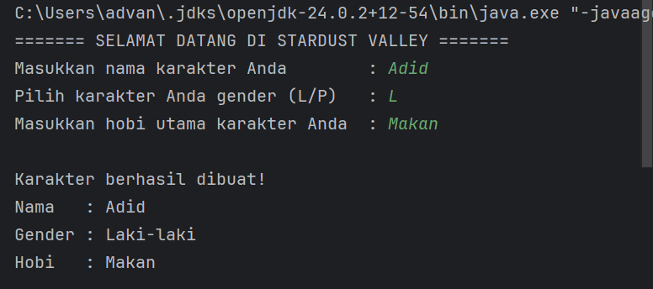
Gambar 2. Screenshot Output Pembuatan Karakter
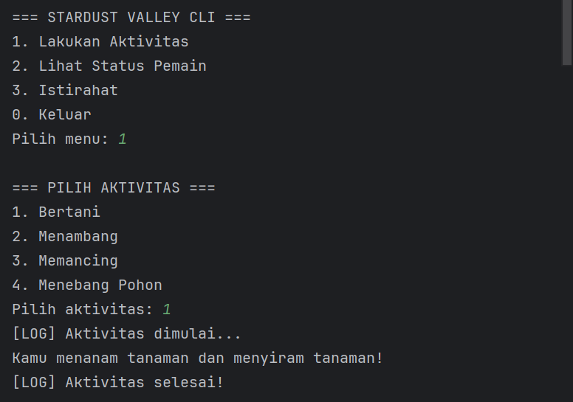
Gambar 3. Screenshot Output Aktivitas Bertani
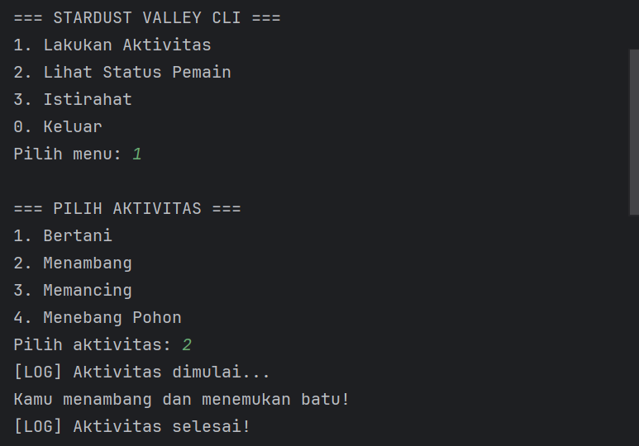
Gambar 4. Screenshot Output Aktivitas Menambang
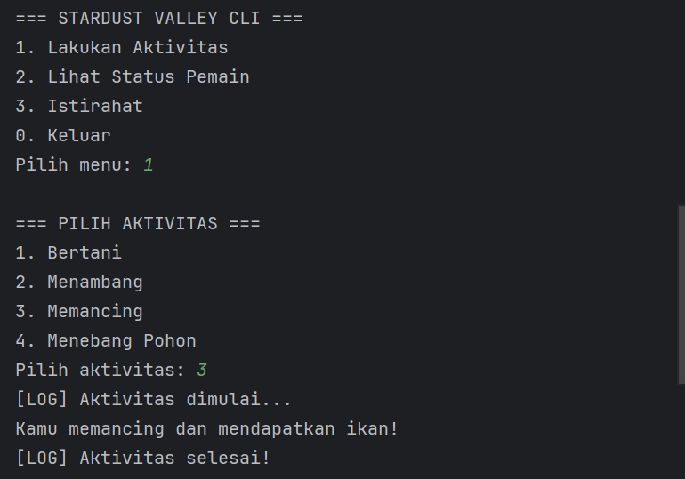
Gambar 5. Screenshot Output Aktivitas Memancing
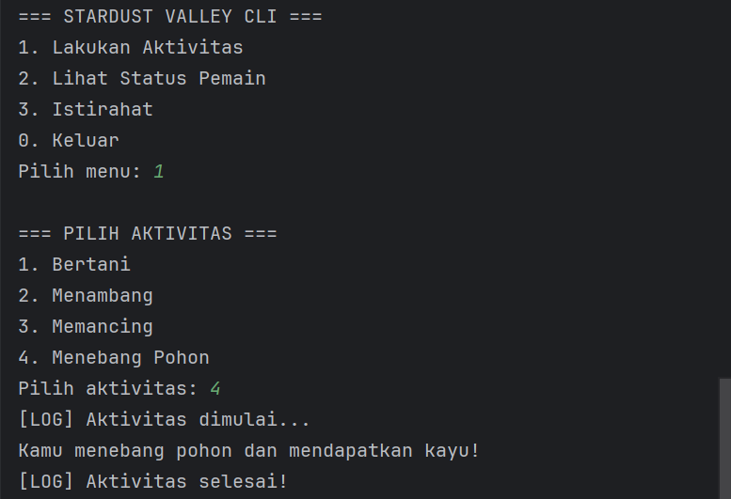
Gambar 6. Screenshot Output Aktivitas Menebang Pohon
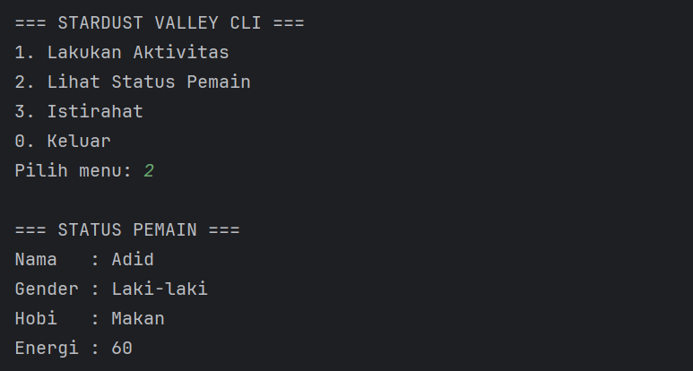
Gambar 7. Screenshot Output Lihat Status Pemain
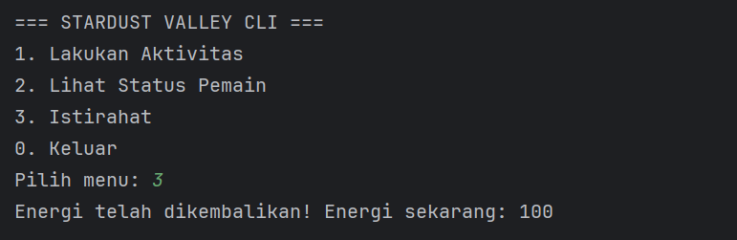
Gambar 8. Screenshot Output Istirahat
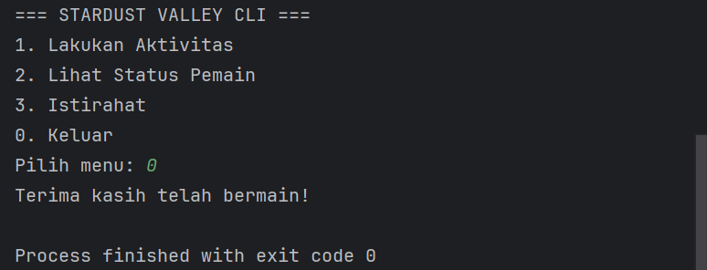
Gambar 9. Screenshot Output Keluar Dari Program

Pembahasan
- Penerapan SOLID
Pada program CLI Stardust Valley, terdapat penerapan Single Responsibility Principle (SRP) pada beberapa class. Class “Main” hanya berfungsi untuk menjalankan program dan memulai game, sehingga tanggung jawabnya terbatas pada eksekusi utama program. Class “Game” hanya bertanggung jawab untuk membuat karakter pemain dan memulai alur permainan, sedangkan MenuHandler hanya menangani interaksi menu, pemilihan aktivitas, dan navigasi antar menu CLI. Class “Player” juga menerapkan SRP karena hanya mengelola atribut pemain seperti nama, gender, hobi, dan energi, serta logika terkait energi. Dengan penerapan SRP pada class-class ini, setiap class memiliki tanggung jawab tunggal sehingga memudahkan pemeliharaan dan pengembangan kode.
Penerapan Open/Closed Principle (OCP) diterapkan pada class “Activity” dan “Tool”. Class “Activity” menjadi class dasar untuk seluruh aktivitas (Farming, Fishing, Mining, Woodcutting) sehingga penambahan aktivitas baru dapat dilakukan melalui subclass tanpa mengubah kode “Activity”. Begitu pula class “Tool” menjadi dasar untuk semua tool (Axe, FishingRod, Pickaxe, WateringCan) sehingga penambahan tool baru dapat dilakukan tanpa memodifikasi class “Tool” yang sudah ada.
Penerapan Liskov Substitution Principle (LSP) terlihat pada subclass-subclass “aktivitas” dan “tool”. “Farming”, “Fishing”, “Mining”, dan “Woodcutting” dapat digunakan sebagai “Activity” tanpa mengubah perilaku program, sedangkan “Axe”, “FishingRod”, “Pickaxe”, dan “WateringCan” dapat digunakan sebagai “Tool” atau “Usable” tanpa menimbulkan bug atau perilaku yang tidak diinginkan. Dengan demikian, semua subclass dapat menggantikan superclass mereka secara polimorfik.
Penerapan Interface Segregation Principle (ISP) diterapkan pada interface “Usable” yang hanya memiliki satu metode use(). Semua class tool (“Axe”, “FishingRod”, “Pickaxe”, “WateringCan”) hanya mengimplementasikan metode yang relevan, sehingga class tidak dipaksa mengimplementasikan metode yang tidak diperlukan.
Penerapan Dependency Inversion Principle (DIP) terdapat pada class “Player”, di mana class ini bergantung pada abstraksi “EnergyStrategy” untuk menghitung dan memanipulasi energi, bukan pada implementasi konkret. Hal ini memungkinkan strategi energi diganti atau ditambahkan tanpa perlu mengubah class “Player”, meningkatkan fleksibilitas dan skalabilitas program.

- Penerapan Design Pattern
Dalam program CLI ini, terdapat beberapa Design Pattern yang telah diterapkan. Class “ActivityDecorator” dan “LoggingActivityDecorator” menerapkan Decorator Pattern (Structural), di mana fungsionalitas logging ditambahkan pada aktivitas tanpa mengubah class “Activity” asli. “LoggingActivityDecorator” menambahkan pesan log sebelum dan sesudah aktivitas dijalankan, sehingga fungsionalitas tambahan dapat diterapkan secara fleksibel.
Kemudian “EnergyStrategy” dan “FixedEnergyStrategy” menerapkan Strategy Pattern (Behavioral), memisahkan logika perhitungan energi dari class “Player”. Dengan pattern ini, strategi energi dapat diganti atau ditambahkan tanpa memodifikasi class “Player”, sehingga program lebih fleksibel dan mudah diperluas.
Kemudian “ActivityTool” dan ActivityToolFactory menerapkan Factory Pattern (Creational), memisahkan proses pembuatan objek “Activity” dan “Tool” berdasarkan pilihan pengguna di menu. Dengan pattern ini, logika instansiasi objek tidak tersebar di “MenuHandler”, sehingga penambahan aktivitas atau tool baru hanya perlu dilakukan di factory tanpa mengubah menu utama.

TAUTAN GIT
https://github.com/Rizki-A-M/PRAKTIKUM-PEMROGRAMAN-II.git

